Amul Ghodasara

200493038

Output: -

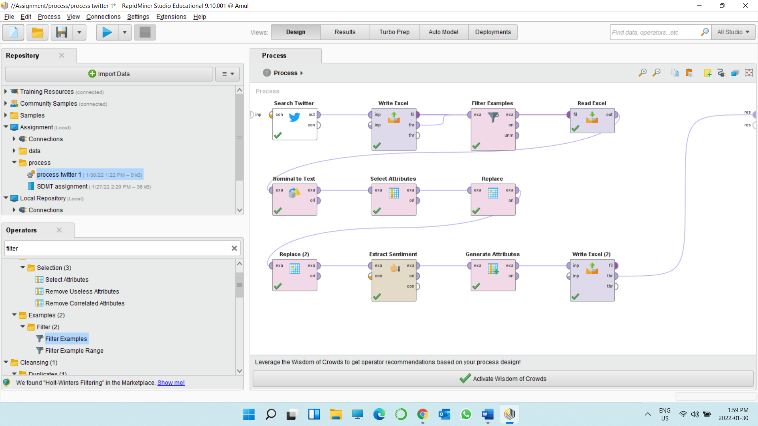

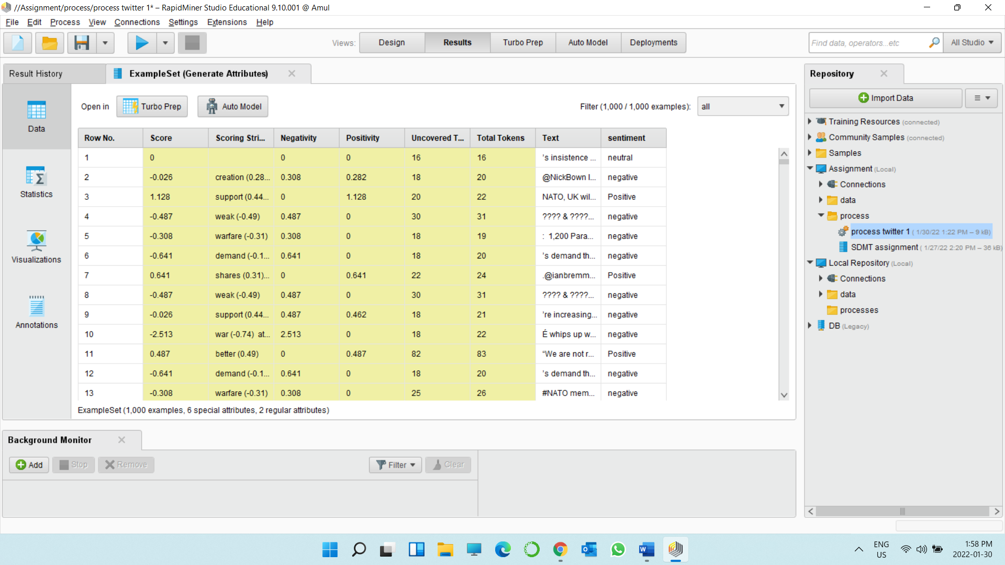

Operators: -

**Search Twitter: -** In search twitter operator, firstly I select repository as a connection source. Main use of search twitter is to get result from query. We have to put any specific word in query field to get twitter statuses for analysis. We can also add limit in it so we can get only that much amount of data, or I can say get that much amount of search result in output. Here, my query work is “nato” and search limit is 1000.

**Write Excel: -** This operator is used for saving that data set into excel spreadsheet. In short, this operator creates excel file that are readable in the user system.

**Filter example: -** The use of filter example operator is to put condition it search result. Here, I put 2 condition it. First condition is “user id should not be missing” and second is “retweet count should be grater and equal to zero”.

**Read excel: -** The use of read excel function is to saved data into excel file which is already downloaded in user system.

**Nominal To text: -** This operator converts all nominal attributes to string attributes. In my analysis, my attribute filter type is all.

**Select Attribute: -** This operator provides different types of filters to make attribute selection easy. In my work, my attribute filter type is single, and attribute is text.

**Replace: -** This operator gives us a freedom us to replace any attribute and add any expression. In my work, I replace “https?://[-a-zA-Z0-9+&@#/%?=~_|!:,.;]*[-a-zA-Z0-9+&@#/%=~_|]” this expression. My attribute type is all. In my second replace operator, I replaced “RT\s*@[^:]*:\s*[A-Za-z ]+” this operator and again my attribute type is all.

**Extract Sentimental:** - In this, my model is Vader and text attribute is text itself. This operator creates a sentimental score.

**Generate Attributes: -** This operator creates new attribute using mathematical expression. Here, I create sentiment attribute and mathematical expression is “if(Score > 0, "Positive", if (Score < 0 , "negative" , if (Score == 0, "neutral","" )))”.

**Write Excel: -** This operator is used for saving that data set into excel spreadsheet. In short, this operator creates excel file that are readable in the user system. This final file I attached in my submission.